**Task 1**

Username: h3594569

**Task 2**

**Method 1**

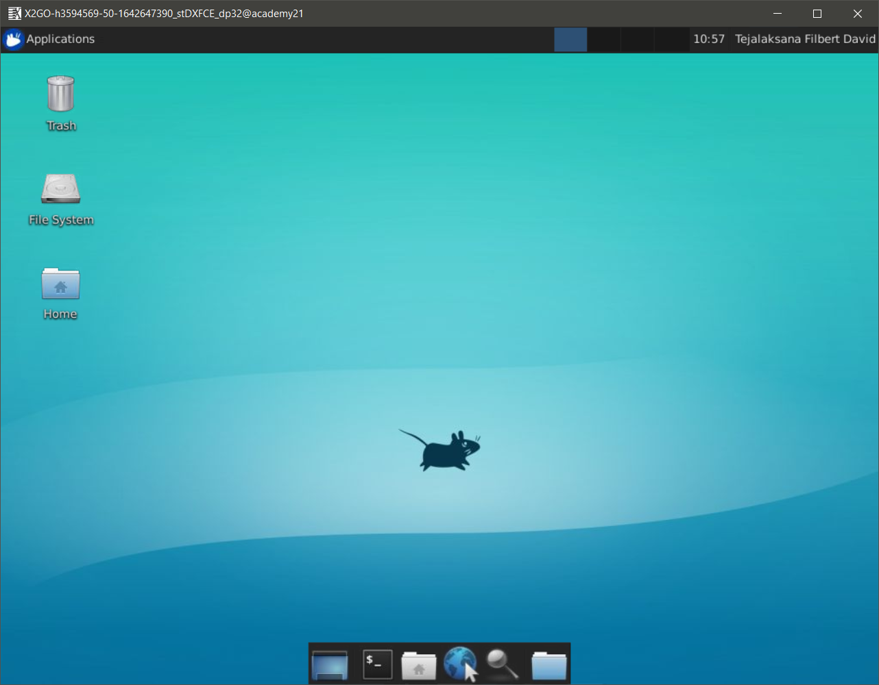

**Method 2**

Wed Jan 19 23:14:37 HKT 2022

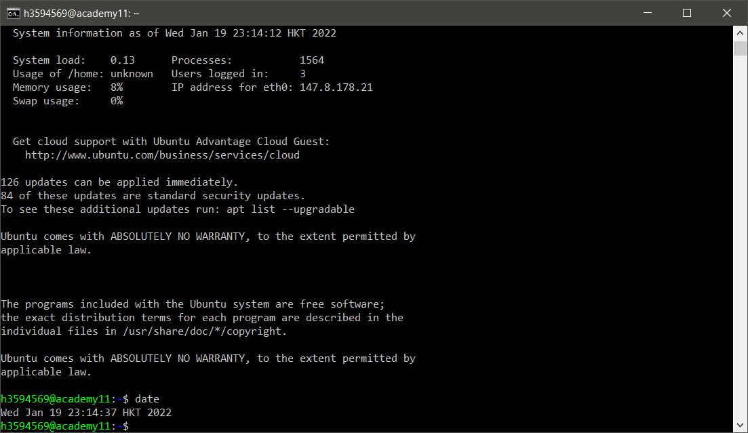

**Method 3**

